

Prospectus 2024

5 English Medium Classrooms
2 Maori Medium Classrooms
‘Te Puna i Keteriki’ is the spring at Otiria. It has been chosen to go underneath the tuna as it is appropriate to the area our school is in.

“Taumarere herehere riri
Te puna i Keteriki
Te rere i Tiria”
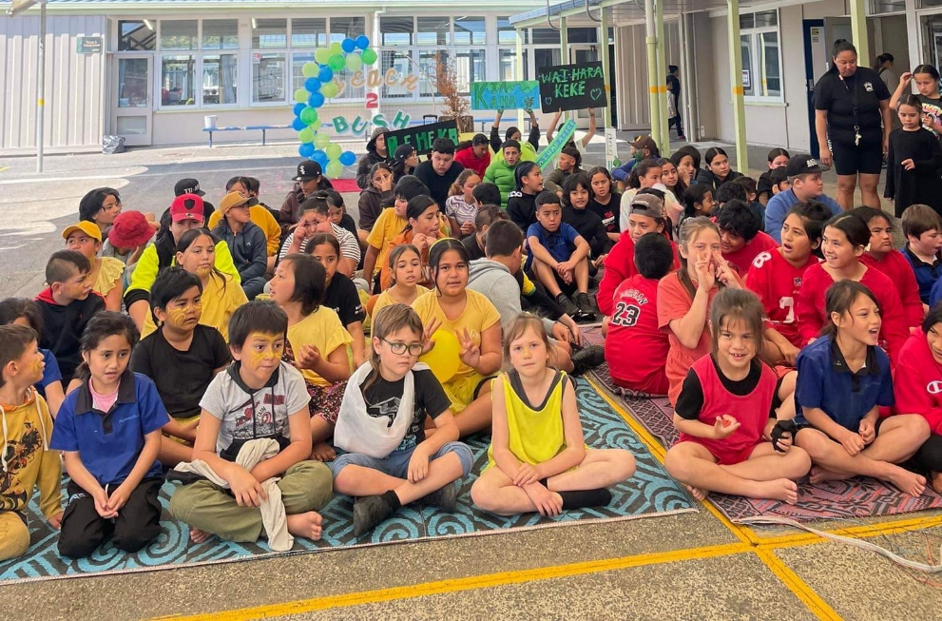
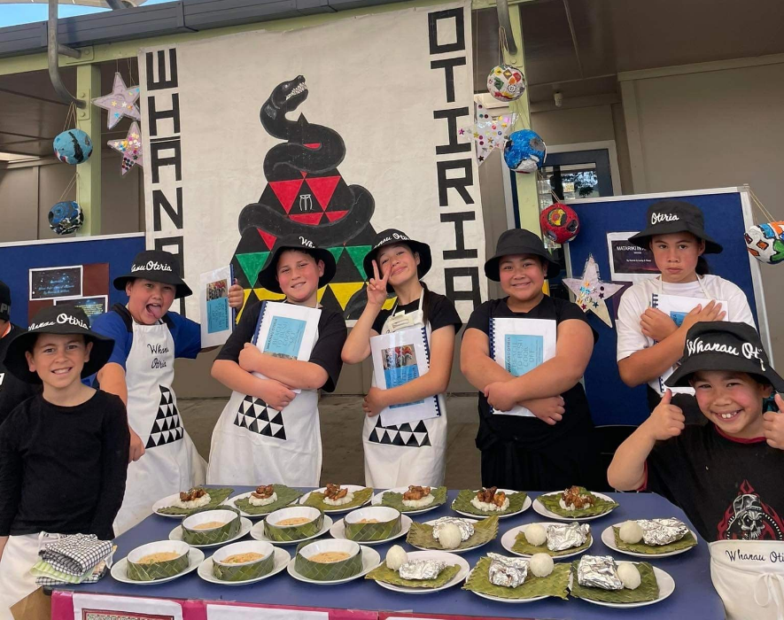
This local whakatauki tells of the baby eels, and their journey when returning from the sea to their rivers. Only by co-operating and working together can they successfully scale the waterfall, Tiria.

Contact Details:
Phone 09 404 1251 or 0800moerewa

Email: office@moerewa.school.nz

4 Year Old Day
Assemblies
Attendance
Behaviour
School Timetable
Board of Trustees & Mission Statement
Bus Pupils
Class Trips
Classroom Organisation
Complaints
Damage to school property
Dental Services
Design Technology Centre
Emergency Management Information
Enrolment
Health
Lunches ~ Healthy School Lunch Programme
Maori Language Programmes
Office Hours
Outside Agencies Involved with the School:
Hauora clinic, PHN visits, Social worker in schools (SWIS)Parent Helpers
Report & Teacher Interviews
School Charter ~ Minutes
Policies
School Fees
School Panui (Newsletter)
Special Programmes
Staff
Stationery
Students Transferring to Another School
Term Dates
Tuckshop / Uniform / clothing/ Naming
Valuables
Your Contact Details
Our School Beliefs ~What our Community want…

Index
In no particular order

INFORMATION FOR CAREGIVERS
====================================

Board of Trustees

BOARD MEMBERS

Del Bristow Presiding Member
Maia Cooper Principal
Margie Mathews Staff Rep
Lorraine King Appointed Parent Representative
Peter Ngaika Parent Representative

Board of Trustee meetings are usually held on the fourth Monday of each month during term time at 3.00 pm in the boardroom. It pays to check with the school office to get exact date or to check time hasn't changed. These meetings are open to the public and everyone is welcome.
The Agenda for Board meetings is set on the Thursday prior to the meeting and any person wishing to put an item on the Agenda must contact the school office before 10.00am on the Wednesday prior.

Mission Statement

To be a happy school, where we all work together, to ensure learning is fun and each child achieves to their personal best.

Principal:Maia Cooper

Team Leaders
Senior Teacher Tere AwateaMargie Mathews
Senior Teacher TaumarereJosie Thompson
Senior Teacher WaiharakekeRaewyn Davis
Senior Teacher OtiriaSophie Brown
Senior Teacher KopuDot Bolous
Teachers:
Taumarere Whanau: Room 3Whaea Shiralee Beazley Y0-4
Room 4Whaea Josie ThompsonY5-7

Otiria Whanau: Room 5Whaea Sophie BrownY0-4
Room 6Whaea Taka BrownY5-7

Waiharakeke Whanau:Room 7Whaea Raewyn DavisY8-10

Tere Awatea Whanau (immersion):
Room 8Margie MathewsY5-7
Room 9Whaea Anita JonesY0-4

Kopu Whanau: Food Technology Teacher:Whaea Dot Bolous
Workshop Design/Creatives Tech:Matua Peter Richards
Whaea Shell Wilson

Support Staff
Teacher Aides:Myrene King Betty ReihanaKarma Potae
Diane Beazley Lauren Tana Karli Baker
Daniel-Ryan TipeneFred Hape
Nicole TanaAmeyah Hape

Office Manager:Jayne Barnett

Caretaker:Sam Brown

Ka Ora, Ka Ako | Healthy School Lunch Programme
ManagerSara Harrington
AssistantJuzz Hau

Resource Teacher of Maori :Huru Tipene

SWIS (Social Worker in Schools)Jim Bailey

Staff 2024
School Timetable

- 8.45am Bell
- 8.50am School starts with assembly/karakia in the hall.

- 10.50am Interval

- 11.10am Block 2 starts

- 12.50pm Lunchtime.
To ensure lunches are eaten pupils remain seated from 12.50 p.m. until 1.00 p.m. (Unless a note is presented or a phone call received NO child leaves the grounds during school hours.)

- 1.35pm Bell. Back to class
- 1.40pm Block 3 starts
- 2.50pm School finishes. Pupils leave from whanau rooms

Office Hours

Office hours are from 8.am to 3.00pm (except Fridays when the office closes at 1pm). daily. Please try to make enquiries, payments etc. during these hours.

Term Dates 2024

Term One: 5 February - 12 April

Term Two: 29 April - 5 July

Term Three: 22 July - 27 September

Term Four: 14 October - 19 December (TBC)

Moerewa School is a composite school. The Ministry of Education expects us to be open for 380 half days in 2024. (see www.minedu.govt.nz) These dates also allow for 3 Teacher Only Days over the year.
School Panui
School newsletters are sent out approximately twice a term. Whanau newsletters are also sent out periodically.

These newsletters are an opportunity to let parents and families know about the specific things that are happening in their child’s classroom and whanau team.
Our facebook page is a good option for keeping up with whats currently happening at school and we encourage whanau to like our page and stay updated.

Important notifications are often sent out by text to main caregiver cellphones so please let us know if your cellphone number changes.

Enrolment
We welcome visitors to the school and are pleased to show intending pupils and their caregivers around before enrolling.

To enrol a child at school, he or she must be five (5) years of age. They can be enrolled on their birthday. It is recommended that the child be accompanied by their parent or caregiver. This enables the parent/caregiver to meet the child's teacher and look at the room in which the child will be taught.

Enrolment packs are available at the school office. When your children first start school the Ministry of Education require that we verify their date of birth. In most cases this is done by sighting the birth certificate. Please also bring along your child’s immunisation records.

Before your child starts you will have a meeting with either the Principal or Deputy Principal. This gives us a chance to get to know you and your child before they start. We can also then ensure teachers are prepared for new arrivals in their classrooms. Either call in or phone 0800MOEREWA to make an appointment and bring along completed forms.

We expect new enrolments to be in full uniform within 2 weeks of starting at Moerewa School.

Classroom Organisation
We group classrooms together in whanau units – and we like to keep family members within the same whanau where possible. A whanau unit will consist of junior and senior classes and they all come together at various times to work collectively.

Maori language Programmes
The school delivers the National Curriculum both in English, in our mainstream classes, and Te Reo in the Kopunui Whanau Unit. There are 2 classes in whanau Kopunui. The junior class deliver instruction from 80% to 100% in Te Reo Maori. The senior class is 50 to 80% in Maori.

Uniform / Clothing/ Naming
Moerewa School has a uniform that is compulsory for all children. We have high expectations regarding uniform, and expect all children to be wearing correct uniform every day. The uniform is available for parents to purchase during the year from our school office. See our uniform brochure for further information.

We also have a limited selection of Kidscan jackets and shoes. These are free to children who need them. Please ask at the office to find out what is available

ALL articles of clothing, footwear, lunch-boxes, school bags etc should be clearly marked with the child’s name. We do have a lost property box at the school. However, if items are not named this makes it very hard to find the owners. Parents are advised to come to school and look at the lost property should an article of their child's be missing. All unclaimed clothing etc... is disposed of at the end of each term. The school does not accept responsibility for items lost or misplaced.

4 Year Old Day
This is for children who will be enrolled at this school. Children who will turn 5 during the current term may visit on Wednesday mornings. They may stay until 12.50pm. Caregivers must accompany their 4 year old during this visiting time.

Attendance
Children are required by LAW to keep regular attendance at school. When a pupil is absent for whatever reason, contact must be made with the school before 9.30am. In cases of frequent unexplained or unjustified absence the Attendance service is notified and also the ‘Rock on’ programme that operates locally in a number of schools. Truancy Officers will follow through with home visits etc. Continued truancy after this point is referred to our local Youth Police Officer.
Automatic phone texts are sent out approx 10am each day if the office hasn’t received a reason for absence. Please reply to texts as the response goes direct to our attendance programme.
For absences phone: 0800MOEREWA extn 4

Dental Services
Our pupils are seen from time to time by the visiting Dental Therapist and Dental Assistant. This service is provided by Ngati Hine Hauora.
If your child needs dental treatment at other times, please phone Ngati Hine Hauora 0800 737 573 or 0800MYTEETH 0800 698 3384

Your Contact Details
Please contact the school office if any of your home contact details change (i.e. address/phone/ cell phone) throughout the year so that we can contact you directly in an emergency situation regarding your child. Please update any emergency contact numbers as well.

Emergency Management Information
In an emergency (i.e. flooding) parents will be contacted, in the first instance, via txt message. Emergency posts will also be put on our school facebook page and regularly updated. Please also see ‘’Bus Pupils’.
Health
If your child is allergic to wasp/bee stings, other allergies or any medication, it is IMPORTANT that the school has details of these. There is an area on the enrolment form for this, and if circumstances change it is important to keep the school informed.

PLEASE inform us when enrolling your child of any medical treatment that should not be given because of religious or cultural beliefs.

If at any stage your child has medication that he/she needs to be given during the day, please see that this is given to the teacher who will see that the proper dosage is given when required.
Children must not hold on to any medication themselves.
Should a child become ill at school, the school will attempt to contact the caregivers. If this is not possible and the child needs medical attention, the school reserves the right to take the child to the Moerewa Medical Centre.

Headlice – The school keeps a small supply of kutu shampoo and combs provided by Kidscan. Please ask at the office.

Behaviour
All children who attend Moerewa School are expected to be well behaved at all times. Teachers are expected to make contact with parents/whanau if your child’s behaviour is not up to expected levels. This will require parents to come into the school, to discuss the issue with your child’s teacher.
We like to focus more on the positive, and reward and acknowledge good student behaviour. We expect children at Moerewa School to be kind to each other, and to actively look for ways to help and support other students at school.
Complaints
We have a complaints procedure that we respectfully request you follow. In the first instance please discuss concerns with your child’s classroom teacher and then the whanau team leader if you are still unsatisfied.
After that any concerns or problems should be directed to the school Principal. Moerewa School always appreciates suggestions on how it can improve aspects of school operation.

Special Programmes
Our school offers programmes to children with identified special needs and with the help of outside agencies, such as Group Special Education and Resource Teachers.

We also employ Teacher Aides with funds specifically allocated for working with children who need individualised tuition. Programmes are developed to meet each child's individual needs. It is expected that the family will be actively involved in the making of Individual Education Plans (IEPs).

Design Technology Centre
Our school has an attached technology centre, with trained Specialist Technology teachers, who provide instruction for our Y7 & Y8 pupils.
This centre also caters for Y7 & Y8 pupils from other schools in the Southern Bay of Islands district.

Outside Agencies Involved with the School
These include: Special Needs Advisor, Teacher for Visually Impaired, Speech Therapist, Public Health Nurse, Mobile Ear Clinic, Advisor on the Deaf, Community Police Constable, Doctor's Clinic, Dental Caravan, Area Truancy Officer, CYPS, Ngapuhi Iwi Social Services, He Iwi Kotahi Tatou Trust, Social Worker in Schools. Regular checks by Area Health Board on vision and hearing.
School Charter / Minutes
The School Charter is available on request from the school office if you wish to read it. . Minutes of Board meetings are available for reading from the school office.

Policies
Policy making is an on-going project and the school has a number of policies presently in place which are also available to be read online

Our SchoolDocs site (URL) is: https://moerewa.schooldocs.co.nz
Username is: moerewa
Password: tunatown
This will give you access to all our policies.

Students Transferring to Another School
If you are leaving the area and will be enrolling your child at another school it is very helpful if you collect your child’s books from his teacher and take them with you to the new school.

Valuables
Children are not encouraged to bring items of value along to school and therefore we will not take any responsibility for them if these items are damaged, lost or stolen.
School Fees
The Board of Trustees does not charge school fees. There may however be some costs for certain activities incurred during school trips, sports teams, other extra-curricular activities, visiting performers, etc... You are kept informed of these by newsletter.

Assemblies
It is part of the kaupapa of the school that any visitors be given a powhiri, therefore assemblies of this type are necessary. Other formal assemblies are held once a fortnight. There is an end of term assembly on the last day of term. Parents /whanau are encouraged to come and enjoy these occasions with us at school.

Parent Helpers
It is an aim of our school to develop the partnership that exists between the school and parent community. To that end parents are welcome to come along and help out whenever possible. We encourage parents/whanau to come into school as often as possible!
However, these days we need to police vet whanau who help out in the school or on school trips. camps etc. Please ask at office for a police vet form. These take a while to come back from the police so allow at least a month prior to any trip or event.

Wilful Damage to School Property
Parents/Caregivers of pupils who wilfully damage school property will be invoiced for partial costs.
Bus Pupils
All bus children are supervised by the Duty Teacher until the arrival of their respective buses. Children are under School control whilst on the bus. The school is serviced by three bus runs - Matawaia, Orauta and Settlement.

In extreme weather conditions such as heavy rain causing flooding it may be necessary for buses to run early. We will try to contact all parents concerned or emergency contact numbers. If we are unable to contact anyone by phone and/or text – we will not put your child on the bus. You will need to come into school and collect your child. This is so that we are never in the situation where we are sending children home in emergency situations, to a house where there is no adult at home.

Reports & Teacher Interviews
Staff are willing to discuss students progress at any time during the year. If you wish to discuss anything with your child's Teacher or their Team Leader please come into the school to talk with us and we will make time to meet with you.

Term 1: A ‘snapshot’ interview will be held with parents during the first 6 weeks of the year. This interview is to let parents know how their child is settling in and where your child’s strengths lie. Your child’s goal setting sheet will also be shared with parents at this first interview.
Term 2: Parents/Caregivers will be issued with a full written report towards the end of Term 2, and parents are expected to come to school to discuss this report with your child’s teacher.
Term 4: Another written report will be distributed during the final week of the school year.

We expect 100% attendance from parents/whanau at all report evenings. This way we can be sure that all families are kept up to date with the progress their child is making at school.

Class Trips
At various times during the year, class trips of an educational nature take place. Parents/caregivers are always informed of these by newsletter or individual class letters, with a full explanation and reason for trip included. Although the school will endeavour to keep costs to a minimum it may be necessary to levy parents/caregivers for some extra-curricular events.

Permission slips & medical information are issued to parents every time so parents have given specific permission for each outing outside the immediate area.
On enrolment an EOTC Blanket Consent form is given to parenrt asking for general permission to take children to areas in our local community that are considered low-risk. The form explains this in more detail.

Tuckshop
The school operates a tuckshop. During morning interval pupils can purchase flavoured milk, juice, moosies, chips, milk biscuits, etc...

Children are asked not to bring foods to school that are high in additives. We do not encourage Twisties, Big’uns, etc… Lollies and fizzy drinks are banned.

Stationery
The school runs a stationery cupboard through which children can purchase all required exercise books, pens, pencils, etc. It is advisable that children purchase through the school thus ensuring that the correct stationery is being used. A note may be sent home with the child when necessary replacements are required. The Stationery cupboard is open from 8.00am to 8.50am everyday.

Ka Ora, Ka Ako | Healthy School Lunch Programme

The school prepares lunches on site for our children. We have refurbished a kitchen specifically for this purpose with staff hired to produce yummy healthy lunches every day. Please ensure you let the office know if any of your children have food allergies.

Hauora Hub Clinic
Held fortnightly, our school whānau need to enrol their tamariki (often done at enrolment). This will enable our nurses to assess, treat and refer as necessary. Any communication regarding tamariki will be done directly with whānau through our Ngati Hine Health Trust Nurses.

If I enrol my child, what services will be offered? – After an initial Health Assessment:
- Respiratory illnesses & screening
- Rheumatic Fever screening
- General skin infections screening
- General health Information (brochures etc) may be sent home with the child
What will a Nurse contact my whānau about?
- If tamariki require a referral to the GP, Ngati Hine Health Trust service OR other specialists
- To discuss a treatment plan for whanau to follow and monitor at home
Any questions that you may have about the services being provided can be answered by phoning the Ngati Hine Health Trust 0800 737 573.

Public Health Nurse
The PHN visits the school fortnightly to check sore throats (will swab) and sores on tamariki Please let the school office know if you prefer you’re child not be seen by the PHN

Social Worker in Schools (Weekly)
Social Workers in Schools (SWiS) is a school-based community social work service, that places a social worker right in the school grounds, bringing together a child or young person’s home and school life.

SWiS provides early assistance and intervention to children and their families when social or family circumstances are causing the child to struggle with education, health or social development. The aim is to see safe, healthy and socialised children with a strong sense of identity, who are fully engaged in school

Referrals can be made by the children or family themselves, the school, or community or Government agencies. Referrals need the consent of the family, as the service can only be successful with the family’s willing participation and engagement.

Our School Beliefs;
(From Moerewa School Strategic Plan)

- We honour the Treaty of Waitangi and Maori rights as tangata whenua. We recognise and celebrate the unique role of Ngati Hine in our community.
- Our school is a place where children, whanau and staff feel safe, and are strong and secure in their own cultural base and language.
- Our children have the right to high quality, innovative academic, social, and cultural learning opportunities and the responsibility to learn from these.

- Whanaungatanga is the basis of school organisation and practice .
- We will foster a climate of trust, honesty and mutual respect
- We will develop reciprocal relationships with our community
which will be of mutual benefit to families and school and which will support our children’s learning.
- We believe that teaching is a reflective profession. We value our teachers and our support staff and will support them in their role and their professional development.

What our whanau want:
Taken from our Community Questionnaire August 2017

- My dream is for my children to do their best with their education. For teachers and parents to help support them. Guide them to achieve their goals.
- I hope that my children will grow to be responsible adults who will go into tertiary education and bring their skills home to help our hapu and area
- I hope my tamariki grow up to be happy. Happy with who they are and proud to be who they are and where they come from.
- To achieve as much and be as great as they can be. Just to help them achieve their dreams.
- I wish for my child to go to university which no family member has done before. As a school you can achieve this by giving my child the skills, confidence, education and social development to achieve this.
- To be confident about their learning / themselves. ie. School is a positive place for them.
- Be respectful to each other
- Be respectful of everyone around them.
- My hope and dreams is that my child enjoys their time at school. Will have lots of memories of things they did and things the school did. We need to make learning fun. Try new things. If it doesn’t don’t work try something else. Take classrooms on school trips. Fundraise as a whole school.
- To be great problem solvers. Solution finders.
- Winning culture in sports, kuku korero and kapahaka.
- To be engaged in our community - big or small.
- Make our school a school to be proud of.
